Lab Exercise 1- Docker Fundamental Commands

Objective
Learn and practice the fundamental Docker CLI commands to:
- Manage images and containers
- Understand container lifecycle
- Build and run applications using Docker

1. Setup
Prerequisites
- Docker installed on your system
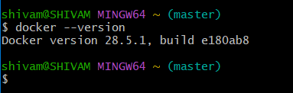
2. Basic Docker Commands
Step 1: Verify Installation
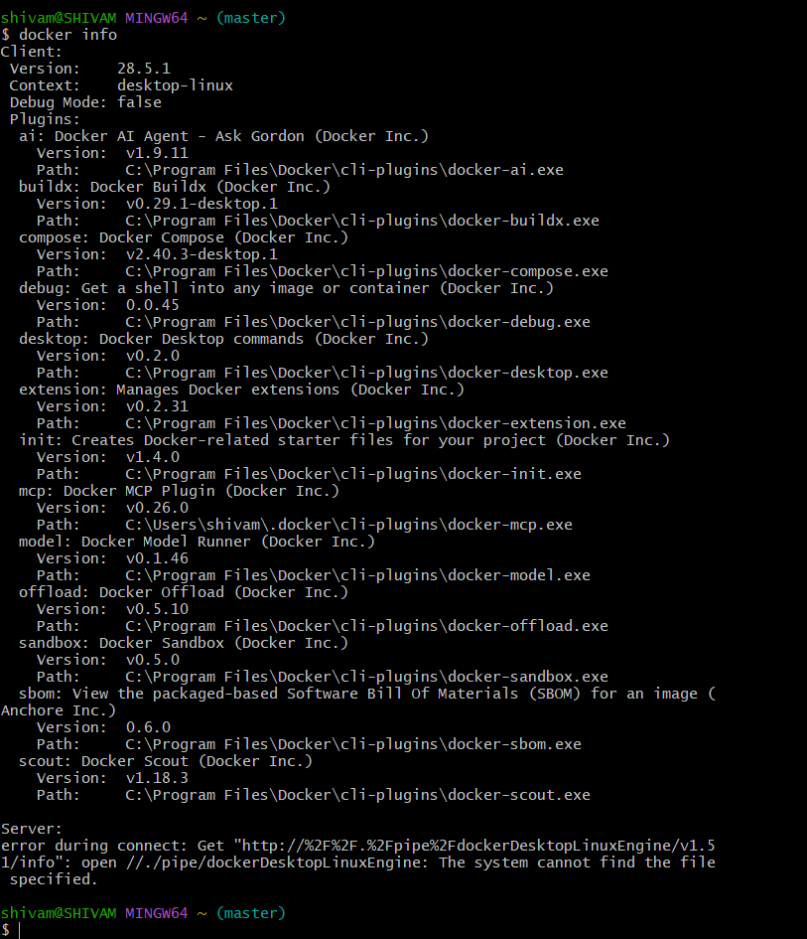

Step 2: Pull an Image from Docker Hub
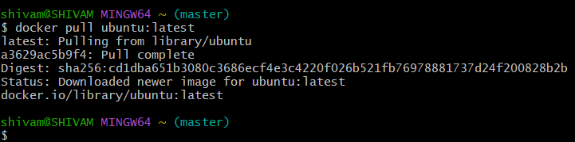Explanation: Downloads the latest Ubuntu image from Docker Hub.
Check available images:
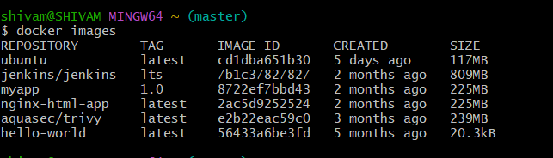
Step 3: Run a Container
Run Ubuntu interactively:
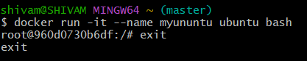

Step 4: List Containers
- Show running containers:
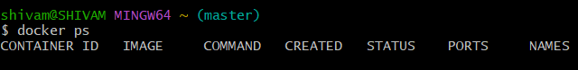Show all containers (including stopped):
Step 5: Start / Stop / Remove Containers
# Start a stopped container
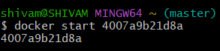
# Stop a running container
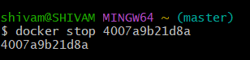
# Remove a container
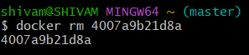

Step 6: Remove Images
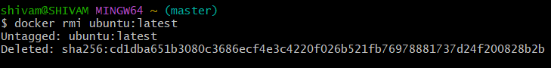Note: You must stop and remove all containers using that image first.

